TABLE OF CONTENTS

- INTRODUCTION
  - PROBLEM STATEMENT
  - PURPOSE
  - SCOPE/ TARGET AUDIENCE
  - TOOLS USED
  - REFERENCES
  - TECHNOLOGY USED
- OVERALL DESCRIPTION
  - PRODUCT FEATURES
  - PICTORIAL REPRESENTATION
    - USE-CASE DIAGRAM
    - ACTIVITY DIAGRAM
    - SEQUENCE DIAGRAM
- EXTERNAL INTERFACE REQUIREMENTS
  - HARDWARE INTERACES
  - SOFTWARE INTERFACES
- NON-FUNCTIONAL REQUIREMENTS

- INTRODUCTION
  - PURPOSE:
The purpose of this SRS document is to provide a detailed overview of our software product, its parameters and goals. This document describes the project's target audience and its user interface, hardware and software requirements. It defines how our client, team and audience see the product and its functionality. Nonetheless, it helps any designer and developer to assist in software delivery lifecycle (SDLC) processes.
  - PROBLEM STATEMENT:
In this fast moving world, every person wants each and everything on the tips of their hands.
But there are still many things which require your precious timings and your physical presence .On such example is Unique ID card generation. After our Honorable Prime Minister, Mr. XYZ made Unique ID card to be the must document for every citizen, it added one troublesome and time taking tasks to their bullet speed life.
Thus, we are here to present one solution for this tiring work.
  - SCOPE/TARGET AUDIENCE:
Since, this project is based on Unique ID card generation which is must for every citizen of India, so target audience will be the whole Indian population who want to get their Unique ID card generated .
  - TOOLS USED:
  - Eclipse
  - REFERENCES:
  - Spring by javatpoint
  - Quora
  - Stackoverflow
  - TECHNOLOGY USED:
  - JSP : For UI based work
  - ORACLE: For database having information about all the people
  - SPRING: Spring is a framework which is an open source Java platform .It provides comprehensive infrastructure support for developing robust Java applications very easily and very rapidly.
- OVERALL DESCRIPTION:
  - PRODUCT FEATURES:
  - It helps you to generate your Unique ID card online.
  - Validation of every field/information you enter into the form.
  - For security purpose, automated OTP by the system is sent to the email entered by the user.
  - Email/Phone no. entered at the time of Sign-Up will first be checked in our database for its presence, so that no two accounts reside on a single entry.
  - For the first timers, an automated password will be provided, which you can change later.
  - At the time of sign in,wrong passwords are allowed only two times. At the third wrong attempt your account will be blocked for 24 hours.
  - In the details entry page, one does not have to enter the default fields like Country, Mobile No/ Email which you have already entered at the time of Login/Signup.
  - Every page will have all the required contact details of the help Desk, to help them at the times of failure or when needed.

  - PICTORIAL REPRESENTATION:
    - USE-CASE DIAGRAM:
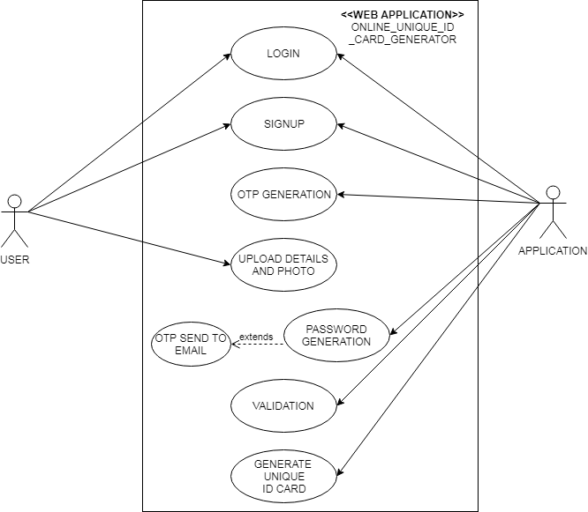

b) ACTIVITY DIAGRAM:
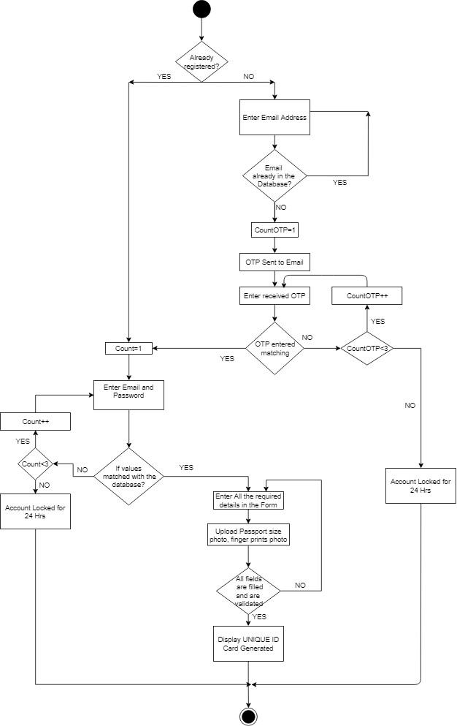

c) SEQUENCE DIAGRAM:
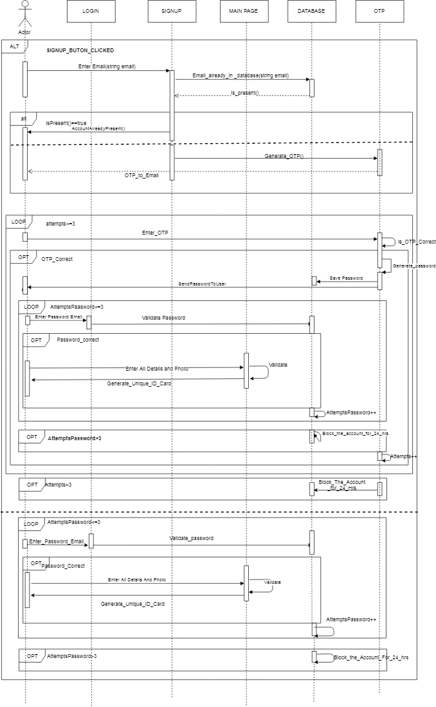
- EXTERNAL INTERFACE REQUIREMENTS:
  - HARDWARE INTERFACES:
  - Windows
  - Browser which supports Jsp,Html.
  - SOFTWARE INTERFACES:
  - Operating System- Windows
  - Database- Oracle
  - Eclipse
- NON-FUNCTIONAL REQUIREMENTS:
  - PERFORMANCE:
    - RESPONSE TIME: The time requirement for request response is way less because we are using Spring to make this application.
    - AVAILABILTY: Since, it is an online Application, so it is available to all the citizens of India 24/7.
    - PORTABILITY: One can access our application from anywhere in the world because it is an online application, just that one would require network connection.
  - DATABASE: Database is designed in such a way that it takes minimum time to hit the data for some query. Also, cardinality of the database is high,which would assist in the better performance. Our practice would be in such a way that least possible Null values will be there in the in the database.
  - SECURITY: We are using Spring Security for the security purpose of our data. It authenticates user before accessing the resources. It locks a particular account for a fixed amount of time, once the no. of wrong attempts are over.
  - CODE QUALITY: Code will be written in such a manner that its modules can be re-used. More over, code will be readable, and could be maintained easily.

